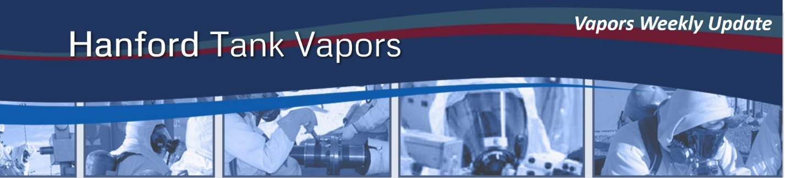
May 4, 2017
From the desk of Mark Lindholm, WRPS President:

Waste-disturbing activity planned in AW Farm

Preparations are underway to operate the Air Lift Circulators (ALCs) in double-shell tank AW-102. The ALCs are routinely operated prior to a 242-A Evaporator campaign to mix supernatant waste prior to processing. The circulators, 22 large pipes suspended vertically in the tank, work by injecting air bubbles into the waste down low in each ALC tube. The bubbles rise, bringing waste up into each tube and mixing it.

During ALC operation, sampling crews will be testing air-purifying respirator cartridges connected to the AW Farm primary exhaust stack. Collecting performance data on filter cartridge performance during waste-disturbing activities is an important part of our vapor program.

The vapor control strategy for this waste-disturbing activity has been reviewed by the Chemical Vapor Solutions Team (CVST) and HAMTC leadership. During operation, the area surrounding AW Farm will be posted as “ACCESS RESTRICTED, ALC OPERATION IN PROGRESS, AUTHORIZED PERSONNEL ONLY, OTHERS CONTACT 373-2689.” Personnel needing access to the area during ALC operations will receive a briefing on the operation and the IH control plan. The authorized personnel list will be maintained at the Central Shift Office in 274-AW.

Additional controls deployed during this operation include the use of supplied air within AW Farm; supplemental AreaRAEs; enhanced IH monitoring and sampling, and monitoring by the RJ Lee mobile laboratory.

News
- WRPS, DOE, the Department of Justice, Washington State, Hanford Challenge and Local 598 will meet again May 18 and 19 for the second round of mediation of a lawsuit filed in September 2015. Should mediation not prove successful, a trial is set for March 2018 in U.S. District Court in Richland.

Opportunities for Employee Engagement
- The next Chemical Vapors Solutions Team (CVST) meeting is Wednesday, May 10, from 2 to 4 p.m. in 2704-HV, Room G-206. Please coordinate attendance with your supervisor.
- The next CVST Communication Sub-Team meeting is Monday, May 15, from 3 to 4 p.m. at 2704-HV, Room B-226.

Mark

